Installation instructions for Exostar's Root Certificate
Open (double click) on the root certificate file (above)
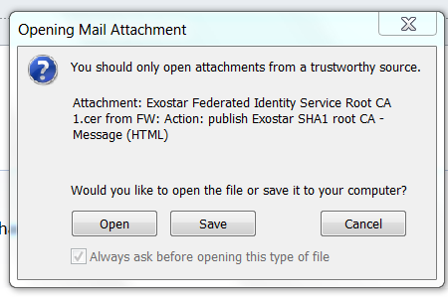

Click “Open” button
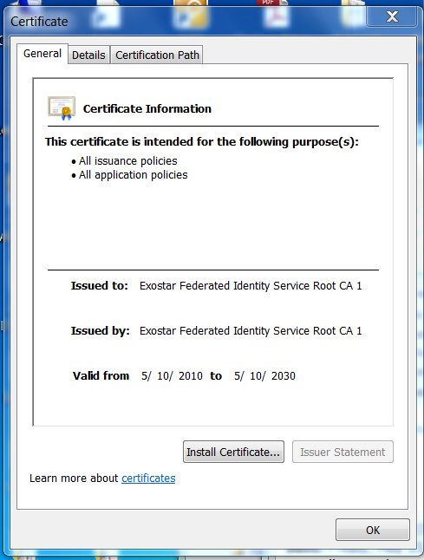

Click "Install Certificate" button
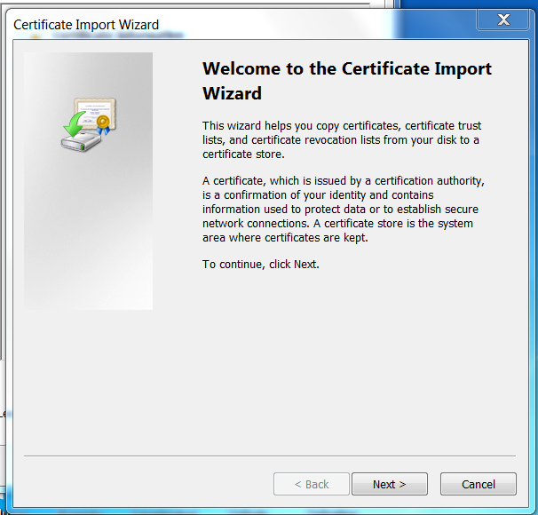

Wizard will open. Click "Next"
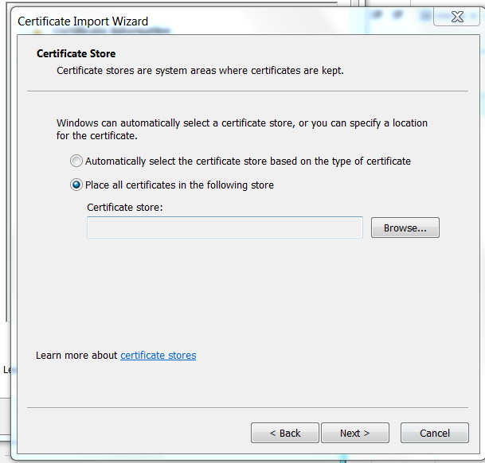

Click radio button next to "Place all certificates in the following store"
Click "Browse" button
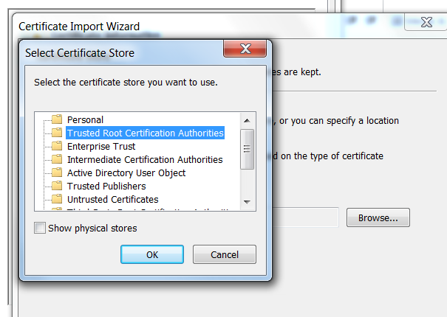
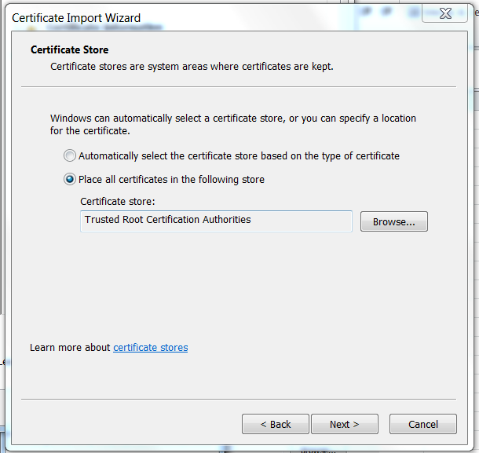

Choose (highlight) "Trusted Root Certification Authorities"
Click "OK"
"Trusted Root Certificate Authorities" will drop into the "Certificate Store" window
Click "Next"
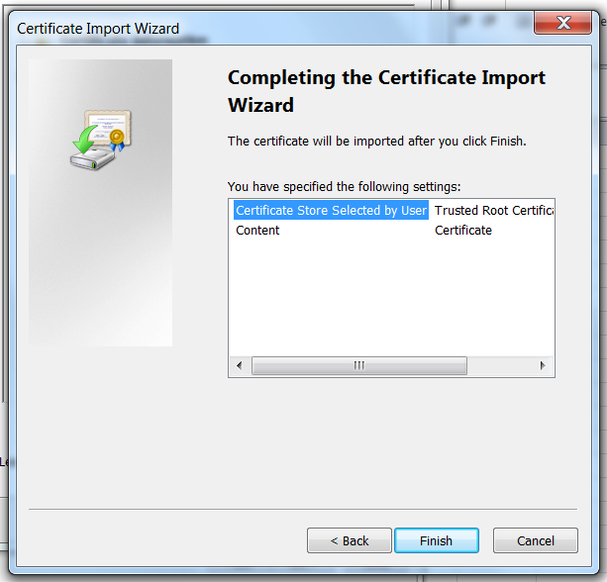

Click “Finish” button
Click “Yes”
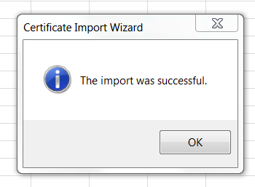
Click “OK” to close

