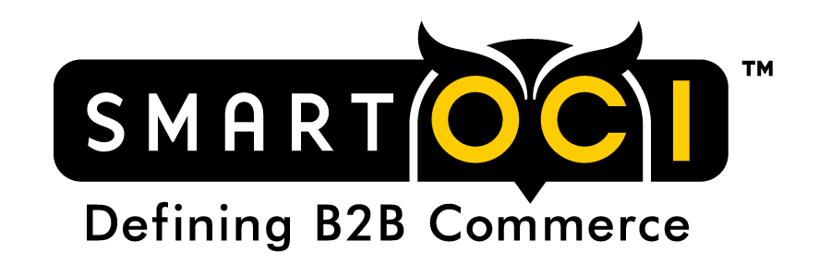
smartOCI™ Supplier Questionnaire

smartOCI Supplier Questionnaire
New Procurement Marketplace System for Northrop Grumman Corporation

Please have your eCommerce person complete this questionnaire and email back to me as soon as possible. I appreciate your support with our project and your quick response will be very much appreciated.

Regards,
Liz Ludlam
eCatalog Content Manager
Northrop Grumman Corporation
Elizabeth.a.ludlam@ngc.com

PART A: ORGANIZATION INFORMATION
Note: This part is intended to provide the business contact information for the company and e-Business division for B2B procurement for the supplier

Company Name
Sales Contact Person
Contact person: Email
Contact person: Telephone

Company eBusiness/e-Commerce Division

eBusiness Contact Person*
Email Address
Contact Person
Website URL
eBusiness Office Location

*Individual or group responsible for managing Punch-Out connections with systems such as SAP, Oracle, JD Edwards, etc.

PART B: SUPPLIER PUNCH-OUT WEBSITE INFORMATION
Note: This part is intended to provide more information about the supplier’s punch-out website and data transfer capabilities

 |  | PUNCH-OUT WEBSITE INFO
 | Do you support the SAP Open Catalog Interface (OCI) format |  |  |  | Yes |  | No
 | Do you transfer UNSPSC codes in the Material Group OCI field? |  |  |  | Yes |  | No
 | Do you support Level 2 Punch-Out capabilities with your e-commerce website? |  |  |  | Yes |  | No
If yes, please indicated the Level 2 punch-out support:
Store (direct home page)
Aisle (shopping department)
Product (direct product page)

 | Do you provide configurable goods on your e-commerce website? |  |  |  | Yes |  | No
 | Do you have policies which prohibit your catalog to be indexed by our new marketplace solution (Note: Existing authentication credentials provided by your organization to your website are leveraged so that our buyers only see our contracted pricing from your website) |  |  |  | Yes |  | No
 | Do you have the capability to submit a catalog file in OCI XML or HTML format of our catalog content and pricing via FTP to a secure server? |  |  |  | Yes |  | No
 | Can you provide a meta keywords list/file of our catalog item/s which we purchase from your site? |  |  |  | Yes |  | No
 | Any additional special functions provided in your punch-out website? Describe below |  |  |  | Yes |  | No
 | Comments:

PART C: OCI CATALOG FIELDS
Field Name | Description | Do you send?  (Enter ‘Yes’ and leave blank for ‘No’) | Supplier Comments
NEW_ITEM-DESCRIPTION | Item short description
NEW_ITEM-QUANTITY | Quantity ordered
NEW_ITEM-UNIT | ISO unit of measure
NEW_ITEM-CURRENCY | Currency Code
NEW_ITEM-VENDORMAT | Vendor part number
NEW_ITEM-MATGROUP | Commodity code; Assumed to be UNSPSC
NEW_ITEM-MANUFACTMAT | Manufacturer Part Number
NEW_ITEM-MANUFACTCODE | Manufacturer Number
NEW_ITEM-LONGTEXT_N:132 | Long Description
NEW_ITEM-LEADTIME | Lead Time of item
NEW_ITEM-PRICE | Item Price
NEW_ITEM-PRICEUNIT | Price Unit
NEW_ITEM-EXT_PRODUCT_ID | Product ID
NEW_ITEM-CUST_FIELD1 | Customer field
NEW_ITEM-CUST_FIELD2 | Customer field
NEW_ITEM-CUST_FIELD3 | Customer field
NEW_ITEM-CUST_FIELD4 | Customer field
NEW_ITEM-CUST_FIELD5 | Customer field
Note: This section provides a list of all OCI Catalog Fields which you may pass to our system. Please enter ‘Yes’ for each OCI field value you pass. If you pass a value to our shopping cart in any of the NEW_ITEM-CUST_FIELD (n), please indicate what the entry is for that field.

PART D: NON-OCI CATALOG FIELDS
Note: This section provides a list of non-OCI fields which you may pass to our system. These fields are for data enrichment and meant to enrich the shopping experience. Please enter ‘Yes’ for each field value you pass.

Field Name | Description | Can you send?  (Enter ‘Yes’ and leave blank for ‘No’) | Supplier Comments
ITEM - IN STOCK | Item in Stock (flag)
ITEM-QTY ON HAND | Inventory on Hand
ITEM-MANUFACTURER-NAME | Item Manufacturer Name
ITEM-BRAND-NAME | Item Brand Name
ITEM-LIST-PRICE | Item List Price
ITEM-MODEL-NUMBER | Item Model Number
ITEM-COLOR | Item Color
ITEM-SIZE | Item Size
ITEM-GENDER | The gender for which this item is targeted
ITEM-RAM | For electronics, RAM Amount
ITEM-CPU-TYPE | For electronics, CPU type
ITEM-HDD-SIZE | For electronics, HDD size in GB
ITEM-SCREEN-SIZE | For electronics, Screen Size
ITEM-SCREEN-RESOLUTION | For electronics, the screen resolution
ITEM-GREEN-CERTIFIED | Flag if the item is certified green
ITEM-UPC | Item UPC
ITEM-CASE-UPC | Item’s Case UPC
ITEM-COMMENTS | Vendor Comments per item

Please indicate any additional fields or values you pass to our shopping cart system during the catalog transfer:

